

**Please send entries / queries to: E-mail: tournaments@icu.ie**

**The 101st Irish Chess Championships 2022**

**Date: 2nd-10th July 20222**

**Venue:** Talbot Hotel, Stillorgan

**Guaranteed Prize Fund**

**Prize fund: €4,000**

**1st: €1,500**

**Time Control**

105 minutes for the first 40 moves + 30 minutes for the rest of the game + 30 second increment from move 1.

**Entry**

**GMs, IMs & FMs: Free**

**Rated over 2200: €50**

**Rated 2000-2200: €75**

**Rated below 2000: €100**

Special: 25% off for Unwaged entrants. ICU ratings alone apply above.

|  |
| --- |
| **Playing Schedule**  **Round 1: Saturday, July 2nd 3pm** |
| **Round 2: Sunday, July 3rd 3pm**  **Round 3: Monday, July 4th 3pm**  **Round 4: Tuesday, July 5th 3pm Round 5: Wednesday, July 6th 3pm Round 6: Thursday, July 7th 3pm Round 7: Friday, July 8th 3pm**  **Round 8: Saturday, July 9th 3pm Round 9: Sunday, July 10th 12.30pm** |

**Current Top Seeds**

**FM Tarun Kanyamarala**

**IM Mark Quinn**

**FM Joe Ryan**

**FM Conor O’Donnell**

**Notes**

1. All players must be current members of the Irish Chess Union.
2. Online entries will be taken on the ICU site - see [here.](https://www.icu.ie/events/986)
3. At least 15 boards will be broadcast online.
4. Entrants must be registered as IRL with FIDE. Event will be FIDE rated.
5. For players rated over 1900 on the July 2018 ICU published rating list.
6. The champion will be awarded a spot on the 2020 open Olympiad team.
7. All sets and clocks will be provided.
8. Further terms and conditions [here.](https://www.icu.ie/articles/670)

**The Irish Championships 2022: First weekender**

**Date: 1st-3rd July 2022**

**Venue:** Talbot Hotel, Stillorgan



**Guaranteed Prize Fund**

**€1,000**

**1st Prize: €500**

**2nd Prize: €250**

**3rd Prize: €100**

**Early Entry Fees**

**Standard: €35**

**Junior/OAP/Student: €30**

**Standard Entry Fees**

**Standard: €45**

**Junior/OAP/Student: €35**

**Late Entry Fees**

**Standard: €50**

**Junior/OAP/Student: €40**

**Time Control**

90 minutes + 30 second increment

from move 1.

**Round Times**

Round 1 Friday, July 1st 7:00pm

Round 2 Saturday, July 2nd 11:00pm

Round 3 Saturday, July 2nd 4:00pm

Round 4 Sunday, July 3rd 10:00am

Round 5 Sunday, July 3rd 2:30pm

Prize-giving Sunday, July 3rd 6:45pm

**Notes**

1. Two sections – Challengers (u1400) and Majors (1300-1900)
2. All players must be current members of the Irish Chess Union.
3. Online entries will be taken on the ICU site
4. All sets and clocks will be provided.
5. Further terms and conditions [here.](https://www.icu.ie/articles/670)
6. Event will be FIDE rated.



**The Irish Championships 2022: Open Weekender**

**Date: 8th – 10th July 2022**

**Venue:** Talbot Hotel, Stillorgan

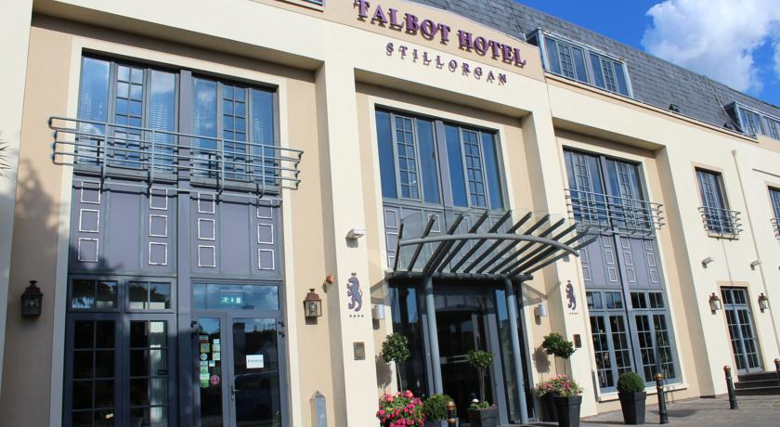

**Grading Band**

For players of any standard – there are no restrictions on rating, age or experience.

**Guaranteed Prize Fund**

**€1500**

**1st Prize: €600**

**2nd Prize: €350**

**3rd Prize: €150**

**Early Entry Fees**

**Standard: €35**

**Junior/OAP/Student: €25**

**Standard Entry Fees**

**Standard: €45**

**Junior/OAP/Student: €35**

**Late Entry Fees**

**Standard: €50**

**Junior/OAP/Student: €40**

**Time Control**

90 minutes + 30 second increment

from move 1.

**Round Times**

Round 1 Friday, July 8th 7:00pm

Round 2 Saturday, July 9th 11:00am

Round 3 Saturday, July 9th 4:00pm

Round 4 Sunday, July 10th 10:00am

Round 5 Sunday, July 10th 2:30pm

Prize-giving Sunday, July 10th 6:45pm

**Notes**

1. All players must be current members of the Irish Chess Union.
2. Online entries will be taken on the ICU site
3. All sets and clocks will be provided.
4. Further terms and conditions [here](https://www.icu.ie/articles/670).
5. Event will be FIDE rated.
6. Event is open to all federations.



**The Irish Championships 2022: Weekday Open**

**Date: 4th – 8th July 2022**

**Venue:** Talbot Hotel, Stillorgan



**Grading Band**

For players of any standard – there are no restrictions on rating, age or experience.

**Guaranteed Prize Fund**

**€700**

**1st Prize: €300**

**2nd Prize: €200**

**3rd Prize: €100**

**Early Entry Fees**

**Standard: €35**

**Junior/OAP/Student: €30**

**Standard Entry Fees**

**Standard: €45**

**Junior/OAP/Student: €35**

**Late Entry Fees**

**Standard: €50**

**Junior/OAP/Student: €40**

**Time Control**

90 minutes + 30 second increment

from move 1.

**Round Times**

Round 1 Monday, July 4th 9:30am

Round 2 Tuesday, July 5th 9:30am

Round 3 Wednesday, July 6th 9:30am

Round 4 Thursday, July 7th 9:30am

Round 5 Friday, July 8th 9:30am

Prize-giving Friday, July 8th 2:45pm

**Notes**

1. All players must be current members of the Irish Chess Union.
2. Online entries will be taken on the ICU site
3. All sets and clocks will be provided.
4. Further terms and conditions [here](https://www.icu.ie/articles/670).
5. Event will be FIDE rated.
6. Event is open to all federations.