ENNIS CHESS OPEN 2022
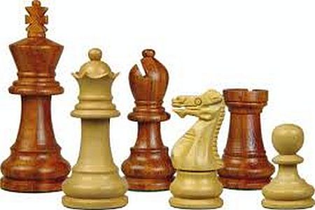

Date: Friday 25th - Sunday 27th, February 2022
Venue: WEST COUNTY HOTEL, Clare Rd. Ennis tel: 065-6869600
Sections: Open Section only, limited to 90 entries
5 Rounds, 1st Round 1 starts @ 8 pm, Friday
Saturday, Round 2 starts @ 10 am, Round 3 - 3 pm,
Sunday, Round 4 starts @ 10 am, Round 5 - 3 pm
Entry Fee: Adults: 40 euro, if paid by Feb 15th, after that 50 euro
Juniors 30 euro
Prize fund(tba) depending on number of entries.
Open:
1st - subject to entry
2nd - subject to entry
3rd - subject to entry
Terms and Conditions:
1. The FIDE Rules of Chess will apply, except where amended below.
2. Players must be vaccinated and provide their Covid Cert for inspection. Details will be recorded with their competition entry. In line with GDPR, information is requested to allow us to to run the tournament safely. At the end of the tournament this information will not be retained. All personal information will be destroyed.
3. All Players, even if triple vaccinated are requested to wear a mask while in the playing area.
4. Players must be ICU members.
5. The tournament will be submitted for FIDE rating.
6. In the event of a tie for first place - a blitz (3+2) will be used to decide the title winner. For any other prize, the following tie breaking system will be applied in this order: Median Bucholz; Bucholz. If players cannot be separated after this, the position shall be shared. No player shall win more than one prize.
7. TIME LIMIT: 90 minutes + 30 sec increment each player for all moves.
8. The default time for games is 30 minutes.
9. Players may request a "Travelling Bye". All communication to the Tournament Director prior to and within 2 hours of the first game. After round 1 all "Travelling Bye" requests should be made to the Arbiter before the end of the previous round.
10. Only one parent(if participant is under 18), will be allowed in the playing hall until play is about to commence. Players who have finished their games shall be considered spectators and should leave the playing hall.
11. Once the game has started, no player shall consult with books, electronic devices or any other player, except the Arbiter until after the game has finished.
12. Mobile phones and electronic devices are not allowed in the playing hall. Should such a device make a noise during a game, the relevant player will be deemed to have forfeited.
13. In the event of any dispute during the game, the players should stop the clock and look for an Arbiter to rule on the issue. The decision of the Arbiter shall be final.
14. Sets & clocks will be provided for all players.
15. At the end of each game, players must set the board up correctly (i.e. White Rook on a1).
16. Sets and clocks must not be removed from the playing room.
17. Clocks must be left at the side of the board where placed by the Arbiter.
18. Spare sets will be available for analysis subject to availability.
Accomodation:
Special discounted rates for all players staying at West County hotel tournament venue. Ask at hotel reception for the special discount rate for Ennis chess tournament players.
Entry Contact: John Cassidy, tel: 065 6824642 or mob.: 087 2495913
Email:ennischessclub@hotmail.com

ENNIS OPEN 2022 ENTRY FORM
Please fill out in BLOCK CAPITALS

Name:___________________________

Address:_________________________
_________________________________
_________________________________

Club:___________________________

Rating:______ I.C.U Number:_____

I request a travelling bye in round:_____

 PLEASE SEND ENTRIES TO:
John Cassidy,
Loyola,
Cusack Road,
Ennis V95FX9D,
Co. Clare

ENTRY FEES:
Adults €40 Juniors €30
Make cheques payable to: John Cassidy
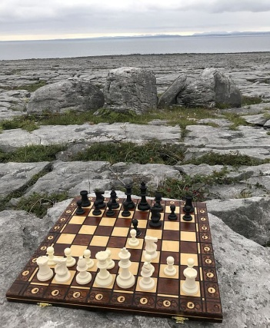
The Burren, Co Clare

