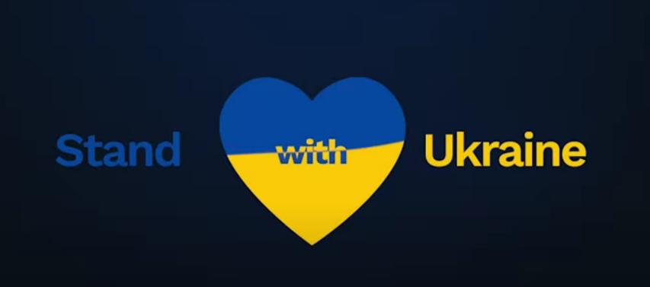
Primary Schools in Ireland have started to integrate Ukrainian children into their classes. And many more Ukrainian children will be arriving soon.
Around Ireland schools and clubs are organising Play for Ukraine days to show these new students that they are very welcome in Ireland. This an opportunity for all students to mix and have fun using games and sports. Each school is encouraged to put their own flavour on their play for Ukraine day and choose a date and activities.
Date: Schools and sports clubs can choose any day during the months of May and June 2022. Activities can be during or after school hours.
Activities: Can be anything that gives Irish and Ukrainian kids a chance to play together and enjoy each other’s company. Making the new students feel welcome using sports, board games, dance and music.
Chess Activity: Chess events have been organised by Moves for Life. These online chess tournaments will be played on Tuesday 31st of May 2022. Chess is a popular sport in Ukraine, so this should be an interesting event for both Irish and Ukraine students.. Chess players can join these events on the MFL website.
Intention: The aim is to foster integration, to help families move from temporary accommodation to more secure family setting, help parents find work and introduce kids to sports clubs (and people) in their new locality. We also hope to raise funds for important humanitarian aid for those who are unable to leave the war zones in Ukraine.
Donate: Anyone (schools, sports clubs or parents) who can help financially please go to our go fund me page https://www.gofundme.com/f/ireland-play-for-ukraine to support this important cause.

